**Ideation Phase**

**Define the Problem Statements**

|  |  |
| --- | --- |
| Date | 29 October 2022 |
| Team ID | PNT2022TMID36299 |
| Project Name | AI-powered Nutrition Analyzer for Fitness Enthusiasts |
| Maximum Marks | 2 Marks |

**Customer Problem Statement Template:**

Create a problem statement to understand your customer's point of view. The Customer Problem Statement template helps you focus on what matters to create experiences people will love.

|  |  |  |  |  |  |
| --- | --- | --- | --- | --- | --- |
| **Problem**  **Statement (PS)** | **I am**  **(Customer)** | **I’m trying to** | **But** | **Because** | **Which makes me feel** |
| PS-1 | Fitness freak | build the muscle | I don’t  know how many  calories i want to eat | Lack of knowledge | angry and feel bad |
| PS-2 | Patient | eat balanced diet | I am not able to eat | I don’t know nutrition content | helpless |

A well-articulated customer problem statement allows you and your team to find the ideal solution for the challenges your customers face. Throughout the process, you’ll also be able to empathize with your customers, which helps you better understand how they perceive your product or service.

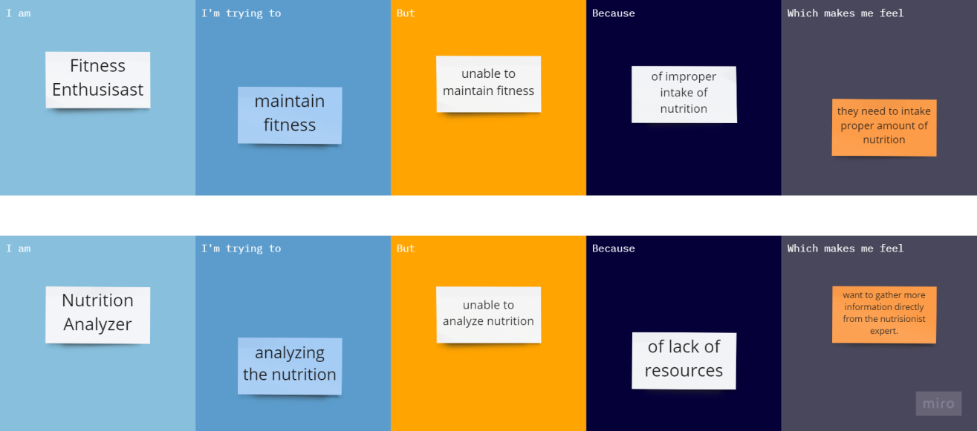

|  |  |  |  |  |  |
| --- | --- | --- | --- | --- | --- |
|  |  |  | proper nutrition food |  |  |